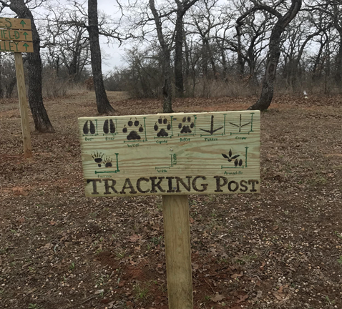
(Photo from Elliott Parkin, 2020)
I have always been connected with the Wasatch Mountain Range from my family teaching me about nature in these areas and how we need to have respect for these lands. Gratefully, Westminster College expanded my knowledge of what is environmentalism and what these lands mean to me. Showing me that it’s much more than just ecological, which environmentalism is also spiritual, communal, diverse, holistic, social justice oriented, and intertwined with many ways to have interfaith or intercultural understandings. Also, that these lands are important for continuing to teach us and that we need to show them mutual respect. They all teach us about the interconnections and interactions occurring within nature, including how we are a part of this living planet and that our behaviors impact these natural relationships.

